Lab 8: Introduction to DevOps, Cloud Computing, and Virtualization

What is DevOps?
DevOps is a software engineering practice that emphasizes collaboration between development (Dev) and IT operations (Ops) teams. This approach aims to improve product quality and accelerate time to market by fostering a culture of continuous integration and continuous delivery (CI/CD). In a DevOps environment, cross-functional teams work together, integrating roles such as developers, IT managers, quality assurance, and security experts to streamline the software development lifecycle.
Key aspects of DevOps include:
- Collaboration: Breaking down silos between teams to enhance communication and cooperation.
- Automation: Utilizing tools to automate repetitive tasks in the development and deployment processes.
- Continuous Improvement: Implementing feedback loops to facilitate ongoing enhancements in both product quality and operational efficiency.
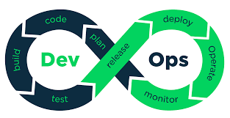

Cloud Computing and Its Relation to DevOps
Cloud computing provides scalable resources that are essential for the rapid development and deployment cycles characteristic of DevOps. By leveraging cloud infrastructure, organizations can quickly provision resources needed for testing and deploying applications. This flexibility allows for continuous updates and improvements post-deployment, which is critical in today’s fast-paced digital landscape.
The integration of DevOps practices with cloud computing leads to:
- Faster Time-to-Market: Rapid iterations enable organizations to respond quickly to market changes.
- Cost Efficiency: Pay-as-you-go models reduce upfront costs associated with hardware.
- Enhanced Collaboration: Cloud platforms facilitate easier sharing of resources among team members.
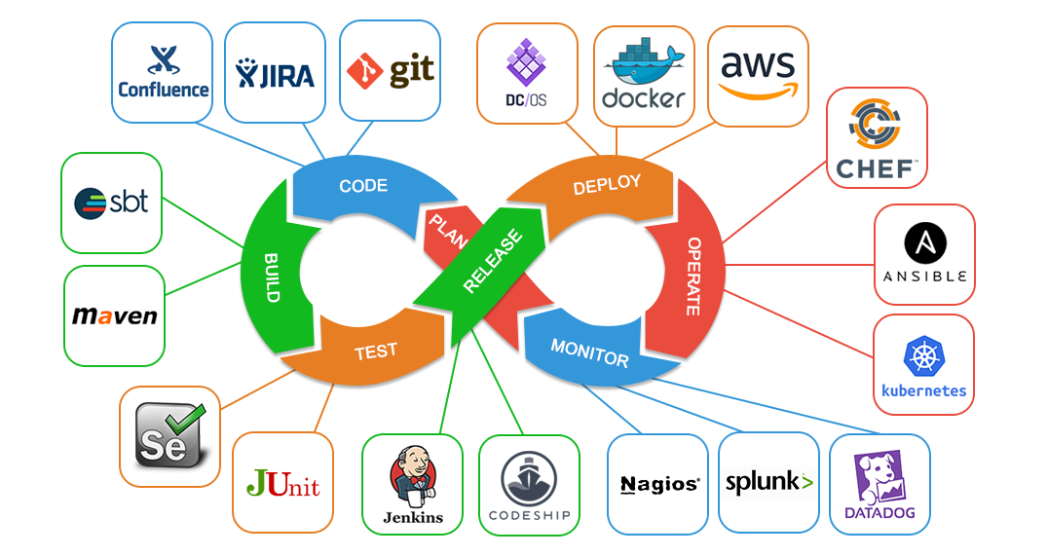

What is Virtualization?
Virtualization refers to the creation of virtual instances of hardware or software resources on a single physical machine. This technology allows multiple virtual machines (VMs) to run independently on a single server, optimizing resource utilization. Each VM operates with its own operating system and applications, simulating an actual physical computer.
Benefits of virtualization include:
- Resource Efficiency: Maximizes the use of physical hardware by running multiple VMs concurrently.
- Consistent Environments: Ensures uniformity across development, testing, and production environments, which is crucial for CI/CD processes.
- Flexibility: Supports various configurations for different workloads without requiring additional physical hardware.
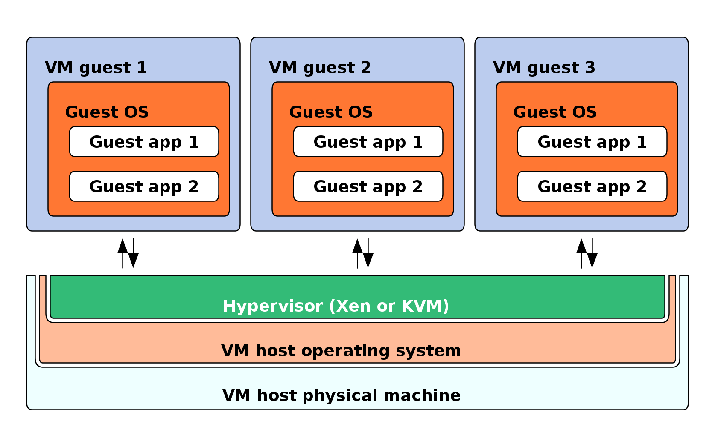

Key Benefits of Virtualization

Resource Efficiency
  - Maximizes the utilization of physical servers by allowing multiple virtual machines to share CPU, memory, and storage resources.
  - Reduces hardware costs by consolidating workloads onto fewer physical machines.

Isolation and Security
  - Each VM operates independently, preventing conflicts between applications running on the same server.
  - Enhances security by isolating applications and services, minimizing the risk of one VM affecting another.

Scalability and Flexibility
  - Enables easy scaling of resources by creating or resizing VMs as needed.
  - Provides different configurations for different workloads without requiring additional physical infrastructure.

Disaster Recovery and High Availability
  - Snapshots and cloning capabilities allow quick recovery in case of system failure.
  - Virtual Machine migration ensures minimal downtime by shifting workloads between physical servers.

Consistency Across Environments
  - Helps maintain uniformity across development, testing, and production environments, which is crucial for DevOps workflows.

Types of Virtualization

Server Virtualization
  - Divides a single physical server into multiple virtual servers.
  - Each virtual server runs its own OS and applications.
  - Examples: VMware vSphere, Microsoft Hyper-V, KVM

Desktop Virtualization
  - Allows users to run desktop environments on a central server instead of individual PCs.
  - Enables remote access to applications from any device.
  - Examples: Virtual Desktop Infrastructure (VDI), Citrix, Microsoft Remote Desktop

Network Virtualization
  - Abstracts physical network infrastructure into virtual components, enabling dynamic network configurations.
  - Examples: Software-Defined Networking (SDN), Virtual LANs (VLANs), VMware NSX

Storage Virtualization
  - Combines multiple physical storage devices into a single, manageable storage pool.
  - Improves storage efficiency and data management.
  - Examples: Storage Area Network (SAN), Network-Attached Storage (NAS), VMware vSAN

Application Virtualization
  - Allows applications to run in isolated environments without being installed on the host system.
  - Improves compatibility and security by preventing conflicts between applications.
  - Examples: Citrix XenApp, Microsoft App-V
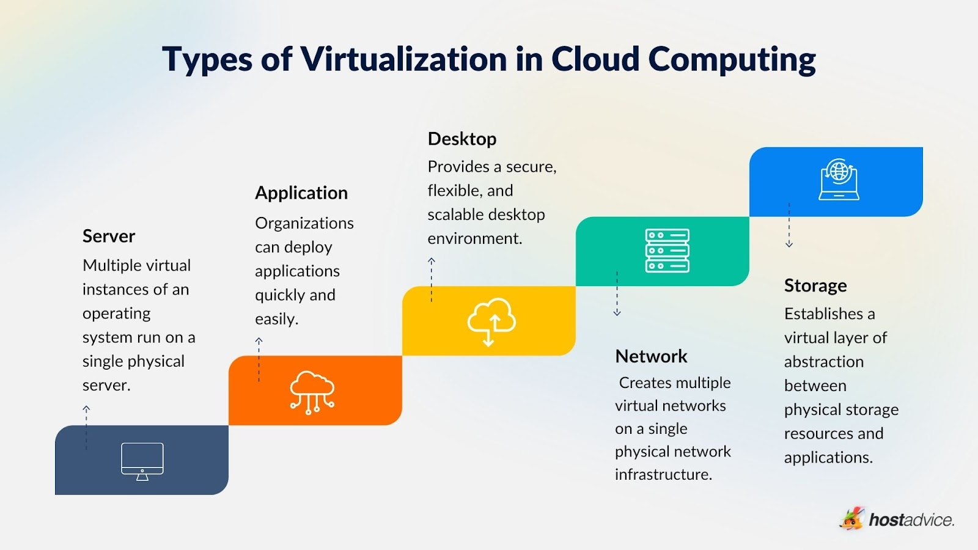

Virtualization Technologies and Tools

Hypervisors (Virtual Machine Managers)
A hypervisor is a software layer that enables virtualization by managing VMs and allocating system resources.

Types of Hypervisors:
- Type 1 (Bare-Metal Hypervisors) – Installed directly on the hardware, providing better performance and efficiency.
  - Examples: VMware ESXi, Microsoft Hyper-V, KVM
- Type 2 (Hosted Hypervisors) – Runs on an existing OS, making them easier to use but with slightly reduced performance.
  - Examples: Oracle VirtualBox, VMware Workstation
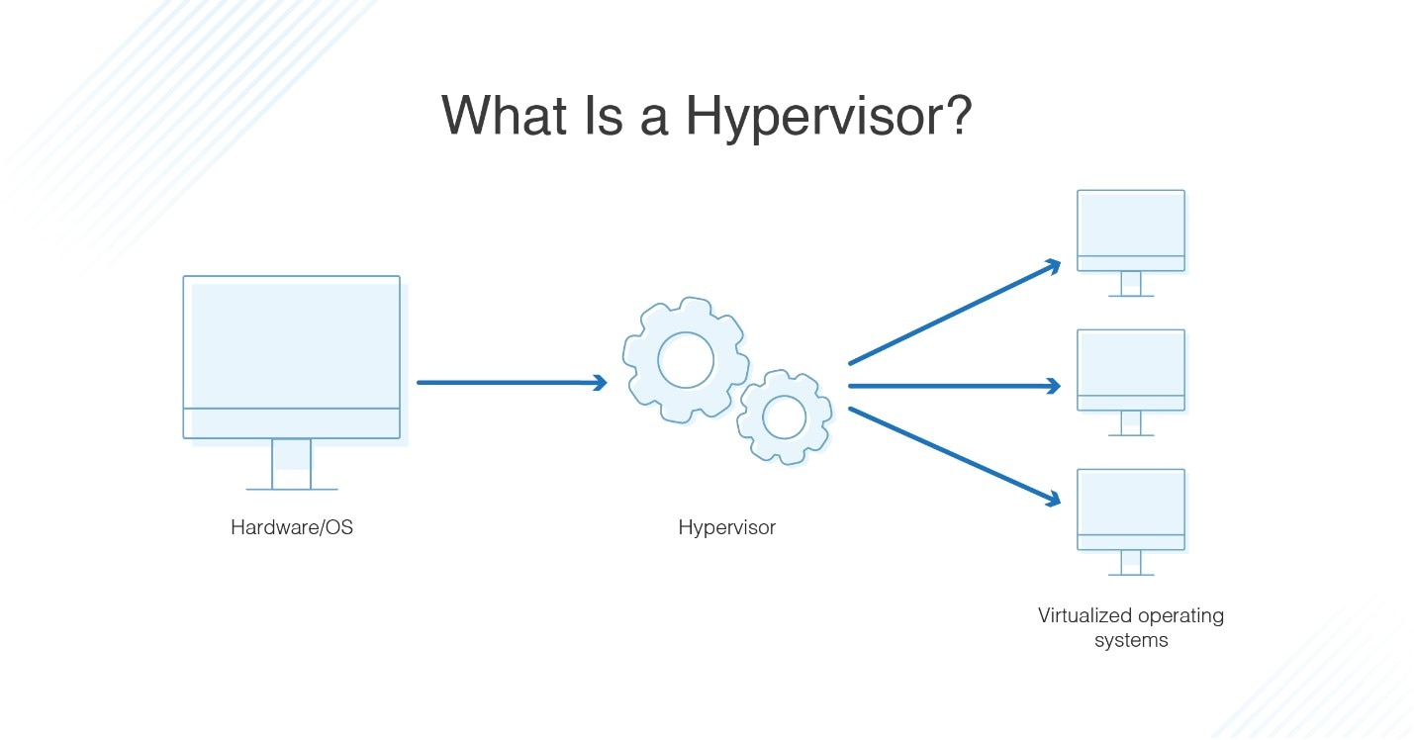

Virtualization Platforms and Tools
- VMware vSphere – Enterprise-grade server virtualization solution.
- Microsoft Hyper-V – Integrated with Windows Server for virtualizing workloads.
- KVM (Kernel-based Virtual Machine) – Open-source virtualization solution used in Linux environments.
- Proxmox VE – Combines KVM and container-based virtualization for flexible deployment.

Role of Virtualization in DevOps
Virtualization is a core component of modern DevOps practices, enabling faster development cycles, improved testing, and efficient infrastructure management.

Accelerating Software Development
- Developers can quickly spin up isolated environments for coding, testing, and debugging.
- Reduces dependencies on physical hardware and allows for parallel development.

Test-Driven Development (TDD) & Continuous Testing
- Virtual environments allow teams to test software under different conditions without affecting production.
- Snapshots enable rolling back to previous states, making debugging and testing more efficient.

DevOps CI/CD Integration
- Virtualization supports Continuous Integration (CI) and Continuous Deployment (CD) by providing consistent and reproducible environments.
- CI/CD pipelines can automatically create, test, and deploy applications within virtualized environments.

Containerization and Virtualization
Virtualization works alongside container technologies like Docker to provide lightweight, efficient solutions for application deployment.
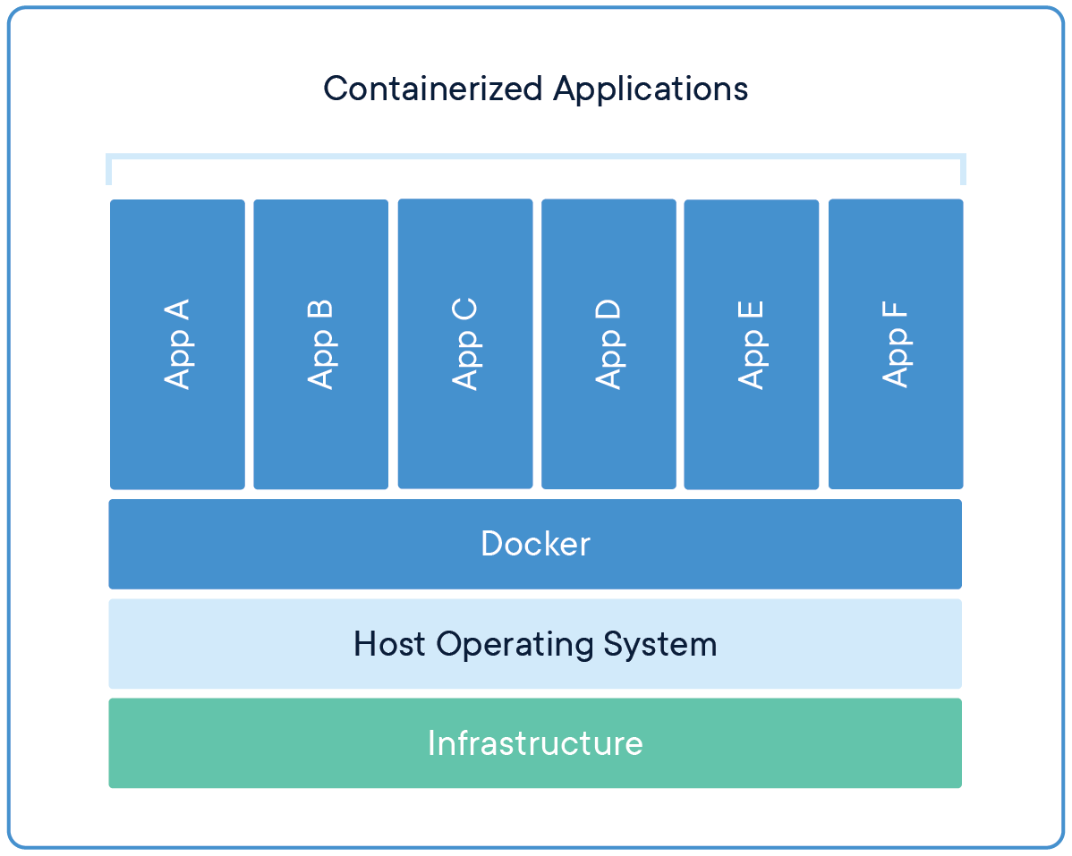
Comparison Between Virtual Machines (VMs) and Containers:
Feature | Virtual Machines (VMs) | Containers
Virtualization Type | Full OS-level virtualization | OS process-level virtualization
Resource Usage | High (entire OS per VM) | Lightweight (shares OS kernel)
Startup Time | Minutes | Seconds
Isolation | Strong (separate OS per VM) | Moderate (shared OS kernel)
Use Case | Multi-OS environments, Legacy applications | Microservices, Scalable applications
Popular tools for containerization: Docker, Kubernetes, Podman

Infrastructure as Code (IaC) & Virtualization
- Virtual machines can be provisioned using Infrastructure as Code (IaC) tools like Terraform, Ansible, and CloudFormation.
- Automates the deployment of VMs across cloud platforms like AWS, Azure, and Google Cloud.

Virtualization in Cloud Computing

How Virtualization Enables Cloud Computing
- Cloud providers use virtualization to offer Infrastructure as a Service (IaaS), Platform as a Service (PaaS), and Software as a Service (SaaS).
- Multi-tenant environments are possible due to VM isolation, allowing multiple users to share cloud resources securely.

Cloud Providers and Virtualization Technologies
- Amazon Web Services (AWS) – Uses EC2 instances (virtual machines) to run workloads.
- Microsoft Azure – Uses Hyper-V-based virtual machines.
- Google Cloud Platform (GCP) – Offers Compute Engine VMs for cloud-based workloads.

Challenges and Limitations of Virtualization

Performance Overhead
  - VMs consume more resources than containers due to full OS virtualization.

Security Risks
  - Hypervisor vulnerabilities can expose multiple VMs to attacks.

Licensing and Cost Management
  - Some enterprise-grade virtualization solutions (like VMware) have high licensing costs.

Complexity in Management
  - Large-scale virtual environments require monitoring and automation tools to prevent resource sprawl.

Steps for Migrating to a DevOps Approach
Migrating to a DevOps culture involves several key steps:
- Understanding Objectives: Define clear goals for the migration process through workshops with stakeholders.
- Infrastructure Assessment: Inventory existing workloads and dependencies to understand current infrastructure capabilities.
- Cross-Functional Team Formation: Assemble teams from development, operations, QA, and security with defined roles during the migration process4.
- Designing Infrastructure as Code (IaC): Use IaC tools like Terraform or AWS CloudFormation to manage cloud resources efficiently.
- Implementing CI/CD Pipelines: Automate deployment processes using tools like Jenkins or Azure DevOps to streamline application updates.
- Monitoring and Feedback Loops: Utilize monitoring tools like Prometheus or Grafana for real-time insights into system health during migration.
- Incremental Migration Strategy: Migrate applications in stages, starting with non-critical systems, to minimize risk during the transition.

Essential DevOps Tools
DevOps relies on various tools that facilitate automation and optimization throughout the software development lifecycle. Key categories include:

Continuous Integration/Continuous Delivery (CI/CD) Tools
These tools automate the processes of code integration, testing, and deployment:
- Jenkins: A widely used open-source automation server that supports building CI/CD pipelines.
- GitLab CI/CD: Integrated within GitLab repositories for seamless project management.
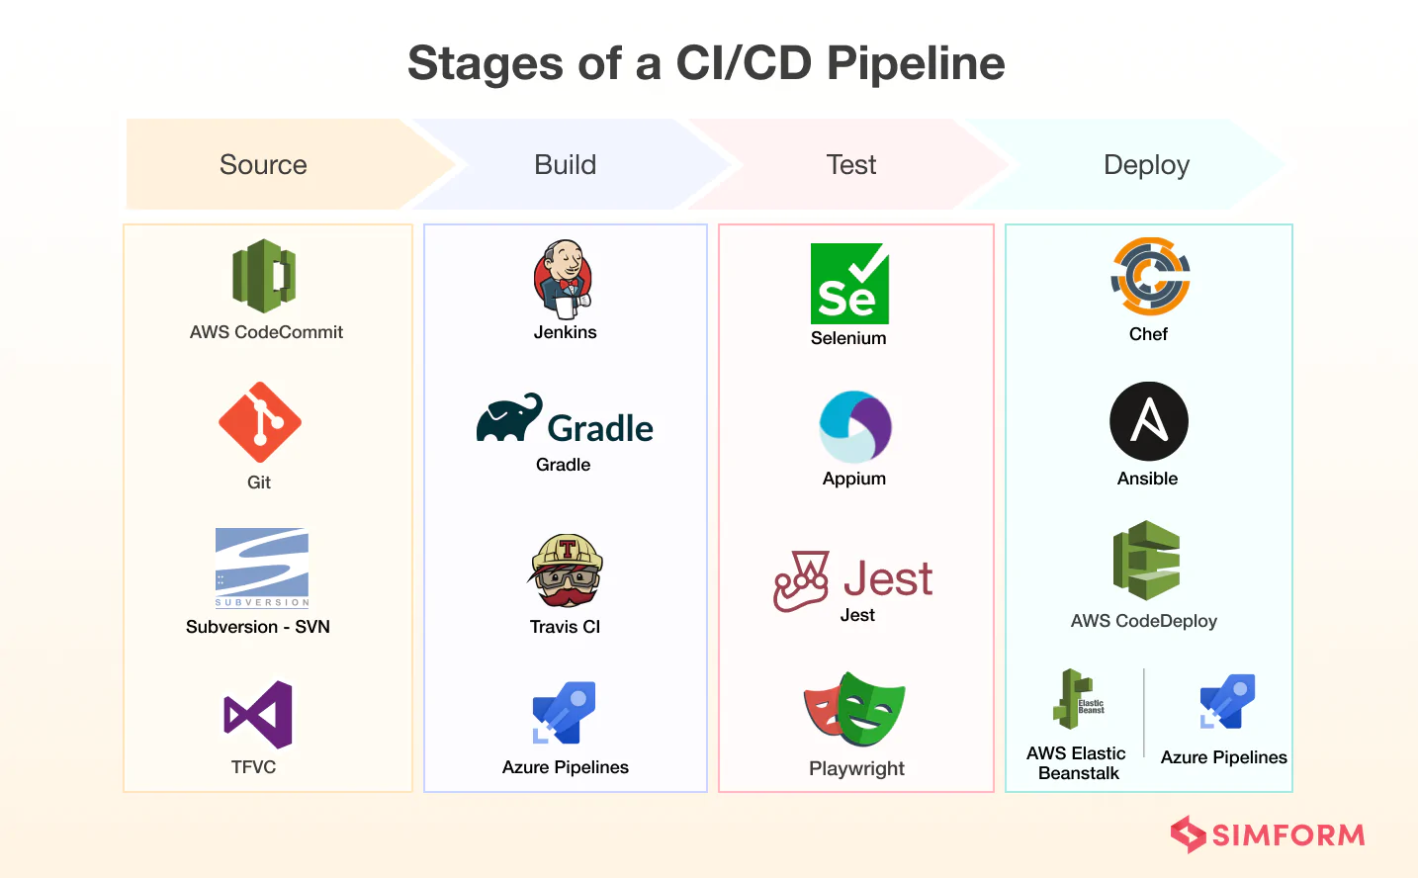

Containerization Tools
Tools that help package applications into containers for consistent deployment:
- Docker: Enables developers to create, deploy, and run applications in containers.
- Kubernetes: Manages containerized applications at scale through orchestration.
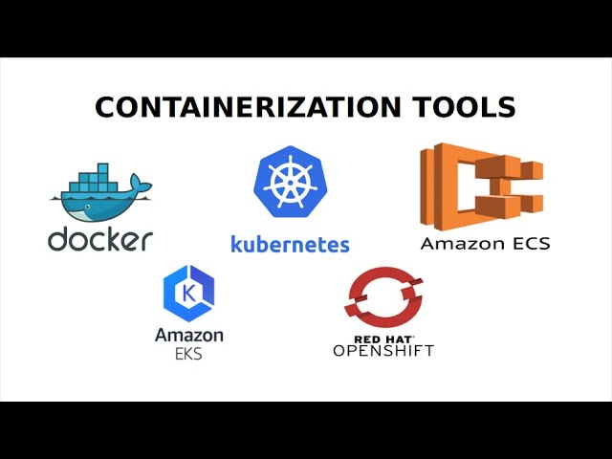

Infrastructure as Code Tools
Tools that automate infrastructure management:
- Terraform: Allows users to define infrastructure using configuration files.
- Ansible: Automates software provisioning and configuration management.
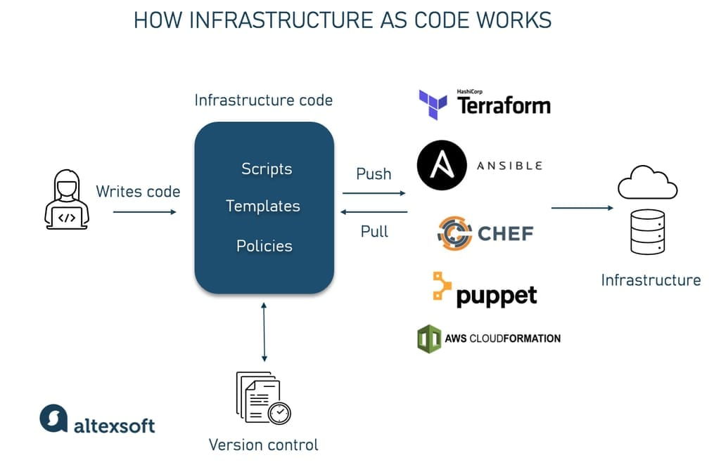

Monitoring Tools
These tools provide insights into application performance and system health:
- Prometheus: Monitors systems by collecting metrics from configured targets.
- Nagios: Offers comprehensive monitoring solutions for IT infrastructure.
By integrating these tools within their workflows, organizations can enhance productivity, reduce errors, and improve collaboration across teams while adopting a robust DevOps culture.

Docker

Introduction to Docker
Docker is an open-source containerization platform that allows developers to build, package, ship, and run applications in lightweight, portable containers. It simplifies application deployment by ensuring that software runs consistently across different environments—whether on a developer’s laptop, a test server, or a cloud platform.

Why Docker?
- Portability: Runs the same way on any system that supports Docker (Windows, macOS, Linux, cloud platforms).
- Lightweight: Containers share the OS kernel, using fewer resources compared to virtual machines (VMs).
- Fast Deployment: Containers start in seconds, making application deployment quicker.
- Scalability: Easily scales applications by running multiple container instances.
- Isolation: Each container runs independently, ensuring process and dependency separation.
- DevOps & CI/CD Friendly: Supports automation, continuous integration, and continuous deployment (CI/CD).

Docker Architecture
Docker is based on a client-server architecture with key components:
- Docker Client: The command-line interface (CLI) or graphical interface used to interact with Docker.
- Docker Daemon (Server): A background service that builds, runs, and manages containers.
- Docker Images: Pre-configured application environments, serving as blueprints for containers.
- Docker Containers: Running instances of Docker images that encapsulate an application.
- Docker Registry (Docker Hub): A repository for storing and sharing container images.

Key Docker Concepts

Docker Images
A Docker image is a read-only template containing everything needed to run an application, including:
- Source code
- Libraries & dependencies
- Environment variables
- Configuration files
Example: A basic Docker image for a Python app may include Python runtime, libraries, and the app’s source code.

Docker Containers
A container is a running instance of a Docker image. It includes application code and dependencies but remains isolated from the host system.
Example: Running a web server inside a container without interfering with the host OS.

Dockerfile
A Dockerfile is a script containing instructions for building a Docker image.
Example: A simple Dockerfile for a Python Flask application:
# Use an official Python runtime as a base image
FROM python:3.9
# Set the working directory in the container
WORKDIR /app
# Copy the application code into the container
COPY . .
# Install dependencies
RUN pip install -r requirements.txt
# Expose the application port
EXPOSE 5000
# Define the command to run the application
CMD ["python", "app.py"]
- FROM – Specifies the base image (Python 3.9).
- WORKDIR – Sets the working directory inside the container.
- COPY – Copies application files into the container.
- RUN – Installs required dependencies.
- EXPOSE – Opens port 5000 for application access.
- CMD – Defines the command to run when the container starts.

Docker Compose
Docker Compose is a tool used to define and manage multi-container applications.
Example: A docker-compose.yml file for a web app and a database:
version: "3"
services:
web:
image: my-web-app
ports:
- "5000:5000"
depends_on:
- db
db:
image: mysql:latest
environment:
MYSQL_ROOT_PASSWORD: root
MYSQL_DATABASE: mydb
- Defines two services: web (application) and db (MySQL database).
- Maps ports (5000:5000) to expose the web app externally.
- Uses depends_on to ensure the database starts before the web app.

How Docker Works (Basic Workflow)
- Install Docker – Download and install Docker on your system.
- Write a Dockerfile – Define how to build an application image.
- Build the Image – Run docker build -t my-app . to create an image.
- Run the Container – Execute docker run -d -p 5000:5000 my-app.
- Manage Containers – List, stop, and remove containers using Docker CLI commands.

Docker Commands
Command | Description
docker pull <image> | Download an image from Docker Hub
docker build -t <name> . | Build an image from a Dockerfile
docker images | List all downloaded images
docker run -d -p 5000:5000 <image> | Run a container from an image
docker ps | List running containers
docker stop <container_id> | Stop a running container
docker rm <container_id> | Remove a container
docker rmi <image_id> | Remove an image

Docker vs Virtual Machines (VMs)
Feature | Docker Containers | Virtual Machines (VMs)
Boot Time | Seconds | Minutes
Performance | Lightweight, shares OS kernel | Heavy, requires full OS
Isolation | Process-level isolation | Full OS-level isolation
Resource Usage | Less (shared kernel) | More (each VM has its own OS)
Scalability | Easily scalable | Limited by hardware resources
Use Case | Microservices, CI/CD, Cloud apps | Running different OSes, Legacy apps

Docker in DevOps & CI/CD
Docker plays a crucial role in DevOps by providing consistent, isolated, and reproducible environments for CI/CD pipelines.
Example: CI/CD Pipeline using Docker
- Developers write code and push it to a Git repository (GitHub, GitLab).
- A CI/CD tool (Jenkins, GitHub Actions, GitLab CI/CD) detects changes and triggers a build.
- Docker builds the application image and runs automated tests.
- If tests pass, the image is pushed to Docker Hub or a private registry.
- A container orchestration tool (Kubernetes, Docker Swarm) deploys the application in production.

